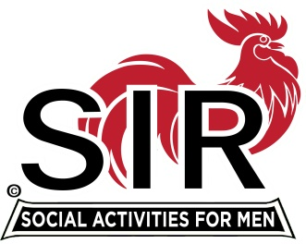
Las Trampas Branch 116
BEC Meeting Agenda
February 21st, 2022, 8:30 AM via Zoom
[Zoom login at the bottom of the agenda]
The Mission of SIR is to enhance the lives of our members through fun activities, events and luncheons – while making friends for life.

8:30 am Call to order; Secretary, Paul Ramacciotti, confirm a quorum and Approval of Jan 17th, 2022 BEC meeting minutes
8:35 Treasurer - Alan Fitzgerald – Report and any updates to 2022 budget
8:40 Standing Reports
- Membership – Phil Goff
- RAMP Department Head Reports:
- Recruitment, Don Schroeder
- Activity Coordinator Mike Ward (potential new activities?)
- Member Relations David Harris
- Publicity Al Farbman
- Covid Compliance - Kevin Donahue (any impacts with lifting of indoor masking?)

8:55 Old Business

March Boundary Oaks Luncheon

- Approved motion: When on February 16th the County of Contra Costa Health Department lifts the requirement for indoor masking at County restaurants and dining facilities for fully vaccinated individuals, SIR Branch 116 will reconvene monthly Branch Luncheons in March as well as other scheduled Dining Out activities conducted by the Branch Dine-O-SIR Group. SIR Branch 116 will continue to comply with any and all Contra Costa County Health Department Guidelines in effect for these activities and will also continue to comply with all State SIR Organization Guidelines in effect for these activities as well as SIR Branch 116 Covid Protocols.

- Contract considerations (Mike Schneider and Alan Fitzgerald)
- Member communications, RSVP efforts, Guest Invitations
- Combining Social Agenda with Brief Business Meeting
- Discuss Table protocols for March and April Luncheon
- Table Survey ( get the good, bad, and Ugly)
- Possible St Patrick’s Day menu and theme for Luncheon

9:35 Little SIR Updates – Roger Craig
Speaker Update and March Considerations (Al Farbman and Roger Craig)
Birthday Boys
9:40 New Business
- Dues communications, deadlines, and follow-up – Alan Fitzgerald
- Launch of Assessment Team: Sam Beret, Steve Bort, Roger Craig, Jim Dawe, Art Donaldson, Tom Eller, Jeff Johnson
- Volunteers Needed: Greeter Leader, Publicity Assistants, D-Team Leader, Recruiting Assistants, Speaker Team Member, Member Relations Assistants

9:55 am Adjourn; Next BEC Meeting March 21st, 2022

Zoom Invitation

https://us02web.zoom.us/j/83498363835
Meeting ID: 834 9836 3835
Passcode: 217854
Dial-In: (669) 900-9128

